A length of 4000–6000 words is recommended.
Title (The first letter of each content word is capitalized.)
Authors and affiliations (format example):
ZHAO Daxue ¹，ZHANG San²，LI Donghua ¹ ∗，LI Xiang ¹
(Surname in full uppercase, given name in initial capital)

1. College of Mechanical Engineering, Donghua University, Shanghai 201620, China
2. College of Textiles, Donghua University, Shanghai 201620, China
(If there is only one affiliation, do not number it.)

Abstract:
The abstract should be informative and include the four main components: purpose, methods, results, and conclusions. It should consist of approximately 120–250 substantive words. The abstract must not be divided into paragraphs or include citations. It should be self-contained and must not reference equation numbers, figure numbers, or citation numbers from the main text.

Keywords: (regular font; separate keywords with semicolons)
Keywords should be accurate, standardized, and reflect the main content of the article. They should also appear in the main text. Generally, 3–8 keywords are required.
CLC number: (Chinese Library Classification number, Query URL: https://www.clcindex.com/category/)
Document code: A
Article ID: 1672-5220(2026)03-0000-00

0 Introduction (with the numbering “0” in accordance with GB/T 7713.2-2022)
The introduction should include the background, purpose, rationale, expected results, and the significance and value of the study. It should review the history, current status, and achievements in related research fields, as well as evaluate their interrelationships. The introduction should also state the objectives of the study, including research goals, theoretical basis, experimental design, and key problems to be addressed. While there is generally no strict length limitation, the introduction should be concise and logically organized to ensure clarity and coherence.
1 Materials and Methods (Level-1 heading) (The first letter of each content word is capitalized.)
1.1 Level-2 heading (Level-2 heading) (Only the first word is capitalized.)
1.1.1 Level-3 heading (Format same as Level-2 heading)
Notes: reagents must specify specifications (if applicable), manufacturer, and country; instruments must specify model, manufacturer, and country.
Example:
Dimethyl sulfoxide (DMSO) was purchased from Adamas Pharmaceuticals, Inc., USA.
The cross-section of the PA-based side-by-side bicomponent elastic fibers was observed by a scanning electron microscope ( SEM) ( S-4800, Hitachi, Japan) with an accelerating voltage of 5 kV.
2 Results and Discussion
2.1 Level-2 heading (Only the first word is capitalized.)
2.1.1 Level-3 heading (Format same as Level-2 heading.)
Notes:
- Variable symbols are single letters in italics; matrices and vectors are in bold italics.
- Subscripts may be used to clarify variable symbols. Multiple descriptors are separated by commas. Superscripts should be avoided to prevent confusion with exponents, matrix transposes, inverse transformations, etc.
- If a subscript is a variable, it is in italics; if it is an abbreviation of a description, it is in regular font.
Examples:
For the force component F_{y}, F is italic, and “y” represents a variable component, so the subscript “y” is also italic.
For the magnetic reluctance R_{m}, R is italic, and “m” is an abbreviation for “magnetic”, so the subscript “m” is regular.
- All symbols in the text and equations must be explained when first mentioned.
- The formula appears before the first quotation in the text, and it should be noted that:
- It is advisable to avoid using expressions that take up more than one line in the text; for example, m/V is preferable to 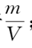.
- It is advisable to avoid using superscripts or subscripts with more than one level in mathematical formulas; for example, P_{1, min} is preferable to P_{1min} .
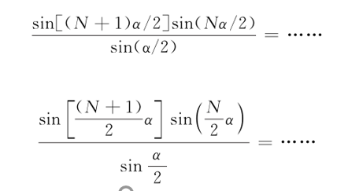
- It is advisable to avoid using expressions that take up more than two lines in mathematical formulas.
Example: Use

Do not use

- Tables are in three-line format.
Table 1 Title (Only the first word is capitalized)
Table header 1 | Table header 2 | Table header 3
Content
Example:
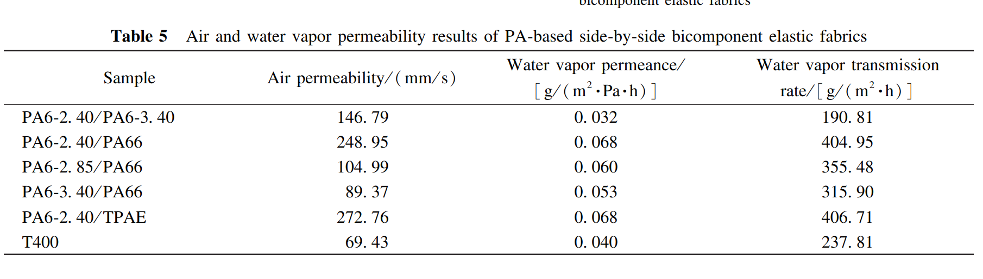
- The physical quantities and units were separated with “/”; the compound units is enclosed in parentheses.
- Figures and Tables should be self-explanatory and appear immediately after they are first mentioned in the text. Figures and tables should be numbered sequentially throughout the text, e.g., Fig. 1, Fig. 2; Table 1, Table 2.
- Figures must be high-resolution and appropriately sized for A4 paper layout (refer to previous issues of this journal for examples). All details should remain clear when printed.
- For figures with subfigures, the caption includes both a main title and subfigure titles. Subfigure labels are placed below each subfigure, as shown in the example below.
- The font of explanatory text in figures should be the same as that of the main text, using Times New Roman.
- Guidelines for figure preparation
a) Tick marks should point inward.
b) Separate physical quantities and units with "/". Physical quantity symbols are italicized, while unit symbols are regular.
c) Enclose compound units in parentheses.
d) Exceptions: "℃" is not enclosed in parentheses; the degree symbol for angles is enclosed in parentheses, i.e., (°).
e) The number of decimal places for numerical values on coordinate axes should be consistent.
f) The physical quantities in axis labels can be expressed as either term words or symbols, but the chosen style must be consistent for both the X and Y axes
Examples：
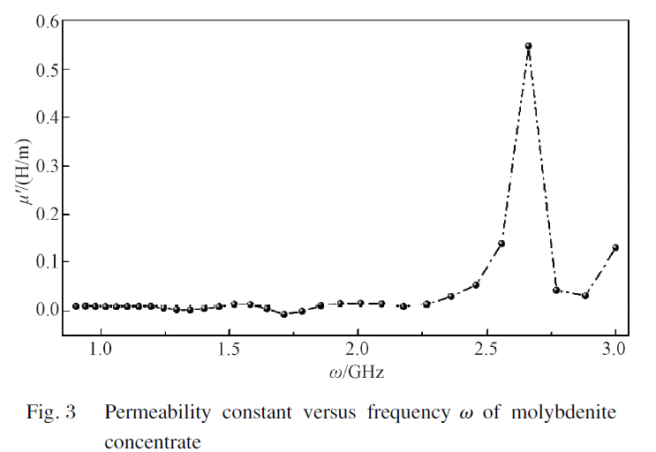
For consistency in decimal precision, numerals must be uniformly formatted (e.g., 1.0, 2.0, 3.0 instead of 1, 2, 3) to match the precision of values like 1.5 and 2.5.
Symbol
Symbol

Compound units enclosed in parentheses
Separated with “/”

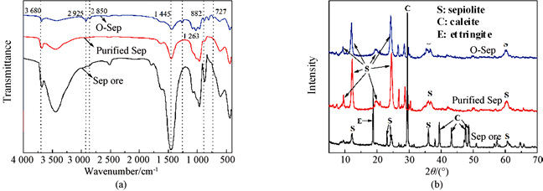
Intensity
The abscissa of XRD patterns is represented by a symbol 2θ, with the unit indicated as "/(°)".
Term
Term
Main figure caption
Subfigure captions; separated by semicolons
Fig. 4 Structural analyses of samples: (a) FTIR spectra; (b) XRD spectra
(a) (b)
Colon
Semicolon

3 Conclusions
（Avoid extensive repetition of the abstract text in the conclusion）

References
References are formatted in accordance with GB/T 7714-2025.
In reference titles, only the first word is capitalized; in journal names, all words are italicized and all content words are capitalized.
Examples：
[1] Xue J J, Wu T, Dai Y Q, et al. Electrospinning and electrospun nanofibers: methods, materials, and applications[J]. Chemical Reviews, 2019,119 (8): 5298-5415.
(Surnames in full with only the initial capitalized; given names abbreviated to initials, capitalized. For Chinese names with multiple characters, the initial of each character should be provided. List the first three authors followed by “et al.”.)
[2] Gandhimathi Xue J J,C, Sundarrajan S, Matsuura T, et al. Fabrication and characterization of high flux poly(vinylidene fluoride) electrospun nanofibrous membrane using amphiphilic polyethylene-block-poly(ethylene glycol) copolymer[J]. Journal of Applied Polymer Science, 2020, 138(17): e50296. (After the colon, specify the page range or reference number of the cited work.)
[3] Formhals A. Process and apparatus for preparing artificial threads: US 1975504[P]. 1934-10-02. (Format for papent: Inventor(s) or assignee(s). Patent title: patent number[P]. Issue date or publication date.)
[4] Crawfprd W，Gorman M. Future libraries: dreams, madness, & reality[M]. Chicago: American Library Association, 1995.
(For books: Note that the city of the publisher must be specified before the publisher's name.)
[5] Liu Z F, Wang B R, Li C L, et al. Fabric defect detection algorithm based on convolution neural network and low-rank representation [C]// The 4th IAPR Asian Conference on Pattern Recognition (ACPR), Nanjing, China. New York: IEEE, 2017: 465-470.
（Format for conference proceedings: Author(s). Title of paper [C]// Name of Conference, Location of Conference. City of publisher: Publisher, year: page range.）
[6] Guo S S. Preparation of PBT electrospun/melt-blown composite filtration materials for blood filtration application[D]. Shanghai: Donghua University, 2014. (in Chinese)
(For Chinese-language references, add "(in Chinese)" at the end of the bibliographic entry; for dissertations, specify the city where the university is located.）
[7] Defferrard M, Benzi K, Vandergheynst P, et al. A dataset for music analysis [PP/OL]. (2017-09-05) [2022-01-02]. https://arxiv.org/abs/1612.01840.
(For electronic documents, it is required to specify both the publication date and the access date, followed by the full URL.）

- The English title of a Chinese-language reference should not be self-translated; consult CNKI (https://www.cnki.net/) for the official English version.


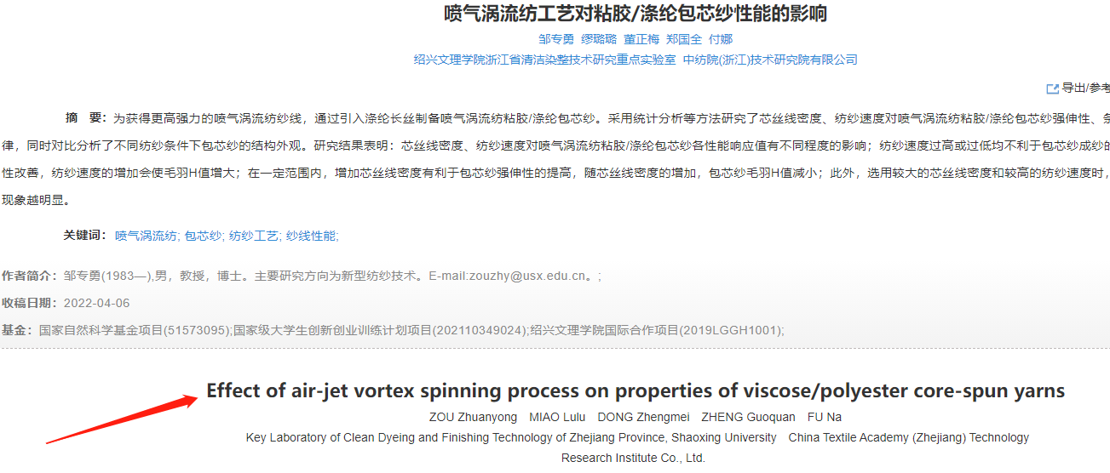

While publishing the full text in English, this journal also includes a Chinese summary. Please provide the Chinese title, authors, affiliations, abstract, and keywords at the end of the English manuscript according to the following example.
基于取向纤维基底和图案化双相金属层的高灵敏应变传感器
If the city is not a municipality directly under the central government, precede it with the province name.
Example: 江苏 南通 226000

刘 璐^{1, 2}，惠鹏先^{1, 2}，刘 飞^{1, 2}，黄莉茜^{1, 2}，蒋秋冉^{1, 2*}
1. 东华大学 纺织面料技术教育部重点实验室，上海 201620
2. 东华大学 纺织学院，上海 201620

摘要：为提升液态金属基应变传感器的灵敏度，研究了一种高灵敏度、可拉伸的应变传感器，该传感器由静电纺热塑性聚氨酯纤维基底和图案化双相金属传感层构成。……（略）
关键词：高灵敏度；应变传感器；纤维取向；双相金属；图案化传感层

Received date: （manuscript submission date，format：2025-01-01） Foundation item: xxxxxx (No. xxxxxx) * Correspondence should be addressed to LI Donghua, email: xxxxxx Citation: Zhao D X, Zhang S, Li D H, et al. Title [J]. Journal of Donghua University (English Edition), 2026, 43(3):000-000 （Please replace yellow-highlighted contents based on the specific context of the manuscript.）

